Humboldt Academy of Higher Learning’s

Fall-o-ween Costume Parade

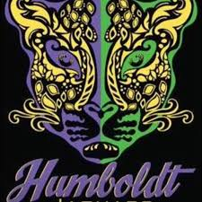

**\**Pictures will be taken***

**\**Parade in the Gymnasium***

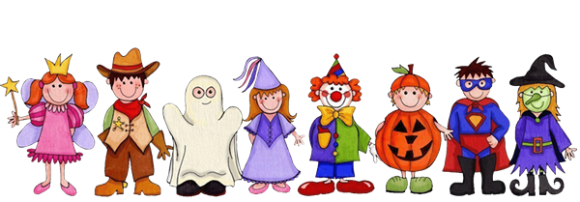

**Date:** **Friday, October 29, 2021**

**Students only, during the school day**

**Time:** **2:00 -4:00p.m.**

**Please Bring Your Costumes**

**Students will be allowed to change into their Costumes after Lunch**

***(Students may only wear appropriate attire. No costume-face masks because we need to wear COVID protection masks)***

For more information: Contact Ms. Belinda Quimby, Principal,

Mrs. Rebecca PriceJones, Family Community Specialist, Mrs. Sierra Blackmon, Secretary. 314-932-5720 or [belinda.quimby@slps.org](mailto:belinda.quimby@slps.org) , [rebecca.pricejones@slps.org](mailto:rebecca.pricejones@slps.org) or [sierra.moore@slps.org](mailto:sierra.moore@slps.org)